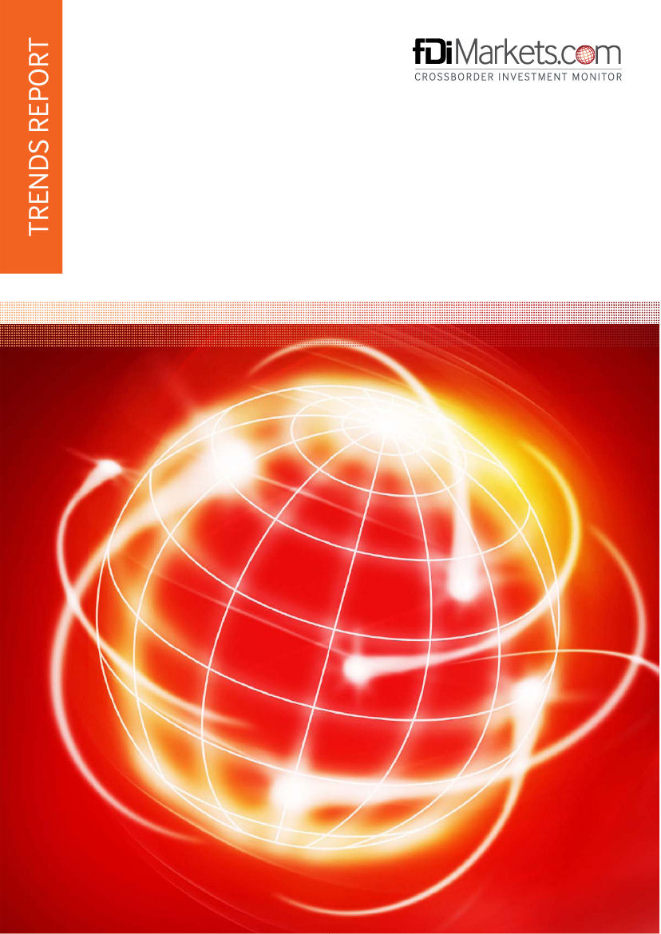
World to COMESA
January 2020 to December 2022
Contents

Introduction | 1
Executive Summary | 2
Key trends | 3
Companies | 5
Industry Analysis: Sectors | 7
Industry Analysis: Business activity | 8
Source countries | 9
Source cities | 10
Destination countries | 11
Destination cities | 12
Project profiles | 13

Introduction

The report examines foreign direct investment (FDI) trends by all companies from seven source regions investing in 21 destination countries between January 2020 and December 2022.  The report includes estimated values on capital investment and the number of jobs created in cases where information was not available at project announcement.
  Headline figures
  No of FDI projects | 710
  Share of global FDI projects | 1.2%
  Total jobs created | 145,581
  Average project size (jobs) | 205
  Total capital investment | USD 167,797.01 m
  Average project size | USD 236.30 m

Executive Summary

FDI projects peaked in 2022
Some 326 projects, or 45.9% of projects, were recorded in 2022. This was the year in which the highest numbers of projects were recorded. During this period a total of 95,981 jobs were created and USD 138.29bn capital was invested by these projects, equating to a 65.9% and 82.4% of total jobs and capital investment respectively.

Key investors account for one quarter of projects.
The top 10% of investors have created a total of 179 projects, 25% of the total projects. These investors have created a combined total of 38,273 jobs, which equates to more than one-quarter of the overall total. The combined capital investment from these companies reached USD 41.23bn, equating to one quarter of the total for all companies.

Business services is top sector with one-eighth of projects.
Out of a total of 36 sectors, Business services accounted for 12.8% of projects. Project volume in this sector peaked during 2022, with 38 projects tracked. Total jobs creation and capital investment in this sector was 11,050 jobs and USD 2.98bn respectively.

Largest projects originate in India
With an average project size of USD 698.50m, projects originating in India are approximately three times larger than the average across all source countries.Ranked seventh in overall projects recorded with 31 in total, India created a total of 9,205 jobs and USD 21.65bn capital investment.

Top five destinations attract the majority of projects.
Out of a total of 20 destination countries, the top five account for the majority of projects. Egypt is the top destination country accounting for almost two-fifths of projects tracked. Total investment into Egypt resulted in the creation of 80,635 jobs and USD 124.11bn capital investment, equating to an average of 290 jobs and USD 446.40m investment per project.

Key FDI Trends

Between January 2020 and December 2022 a total of 710 FDI projects were recorded, equating to a 1.2% share of global FDI. These projects represent a total capital investment of USD 167.80bn, which is an average investment of USD 236.30m per project. During the period, a total of 145,581 jobs were created.

The largest number of projects was announced in 2022, with 326 projects that year equating to a 1.5% share of global FDI. in 2022 was also the year where the average capital investment was at its highest. In terms of job creation, this year has seen the highest average project size of 294 jobs per project.

Headline FDI trends by year
Year | Number of projects | % growth per annum | Jobs created |  | Capital investment
Year | Number of projects | % growth per annum | Total | Average | Total (USD m) | Average (USD m)
2022 | 326 | 68.9 | 95,981 | 294 | 138,290.20 | 424.20
2021 | 193 | 1 | 23,493 | 121 | 21,480.80 | 111.30
2020 | 191 | n/a | 26,107 | 136 | 8,026.00 | 42.00
Total | 710 | n/a | 145,581 | 205 | 167,797.00 | 236.30
Source: fDi Intelligence from The Financial Times Ltd

When allocated into bands, projects creating 100 jobs or more represent more than one-third of projects, while projects creating between 25 and 49 jobs represent almost one-quarter of projects.

Number of FDI projects by jobs created and year
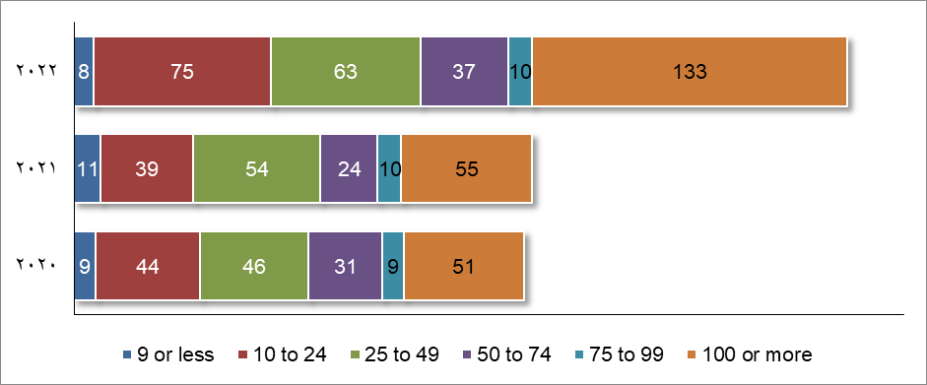Source: fDi Intelligence from The Financial Times Ltd

In terms of project type, 89.7% of projects are new investments. New projects have an average capital investment of USD 231.10 million and job creation of 193 per project.  The average capital investment for expansion and co-location is USD 298.30 million and USD 96.40 million respectively. The average number of jobs created in these project types is 328 and 36 respectively. | Number of projects by type  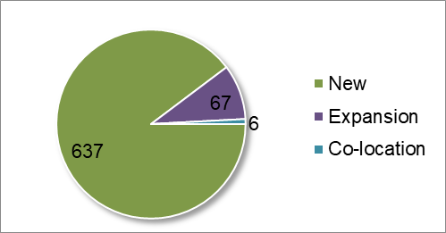  Source: fDi Intelligence from The Financial Times Ltd

Companies

A total of 544 companies from seven source regions invested in 21 destination countries between January 2020 and December 2022, out of a total 28,893 companies investing in FDI globally.

Number of companies by year and percentage of all companies
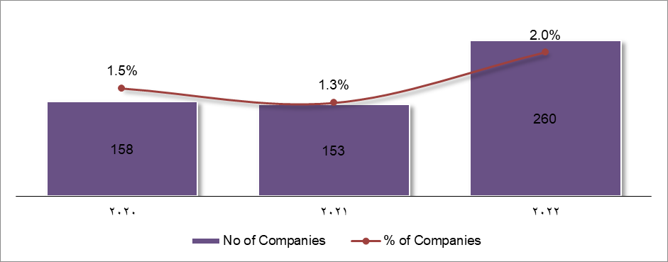Source: fDi Intelligence from The Financial Times Ltd

The top 10 companies accounted for a combined total of 59 projects (8.3% of projects). Within the past 12 months, seven of the top 10 companies have announced projects, with Majid Al Futtaim Group (MAF Group) being the top investor for this period with seven projects.

Top 10 companies: number of projects
Company name | Source country | No of projects | Global projects* | % of global projects** | Projects in last 12 mths
Majid Al Futtaim Group (MAF Group) | UAE | 14 | 106 | 13.2 | 7
Azadea Group | Lebanon | 8 | 105 | 7.6 | 4
Kuehne + Nagel International | Switzerland | 7 | 216 | 3.2 | 7
China Mobile International (CMI) | China | 6 | 31 | 19.3 | 0
Africa Data Centres | Mauritius | 6 | 19 | 31.5 | 3
Move One | UAE | 5 | 22 | 22.7 | 0
AMEA Power | UAE | 4 | 12 | 33.3 | 4
Ivanhoe Mines | Canada | 3 | 3 | 100 | 2
Waypoint Port Services | Switzerland | 3 | 7 | 42.8 | 0
Haussmann Group | Kenya | 3 | 18 | 16.6 | 1
*Total number of projects worldwide from the company regardless of report criteria.
** The share of global projects from the company which match report criteria.
Source: fDi Intelligence from The Financial Times Ltd

The top 10 companies account for 6% of job creation and 7% of capital investment. Collectively, they create smaller projects in terms of job creation at 149 jobs on average. These companies generally provide lower capital investment at an average of USD 198.56 million per project.

Top 10 Companies: Jobs Created and Capital Investment
Company Name | Jobs created |  | Capital investment
Company Name | Total | Average per project | Total  (USD m) | Average (USD m)
Majid Al Futtaim Group (MAF Group) | 3,082 | 220 | 385.50 | 27.50
Azadea Group | 1,971 | 246 | 70.60 | 8.80
Kuehne + Nagel International | 140 | 20 | 57.40 | 8.20
Africa Data Centres | 342 | 57 | 499.80 | 83.30
China Mobile International (CMI) | 420 | 70 | 583.90 | 97.30
Move One | 100 | 20 | 41.00 | 8.20
AMEA Power | 480 | 120 | 6,235.40 | 1,558.80
AFR-IX Telecom | 108 | 36 | 14.10 | 4.70
Alfanar | 1,696 | 565 | 3,661.00 | 1,220.30
Bollore Transport & Logistics | 440 | 146 | 166.40 | 55.50
Source: fDi Intelligence from The Financial Times Ltd

In terms of company size, more than one-third of companies have an annual turnover of USD 5.00 billion or higher, while one-eighth of companies have a turnover of USD 24.99 million or less.

Size of companies by turnover
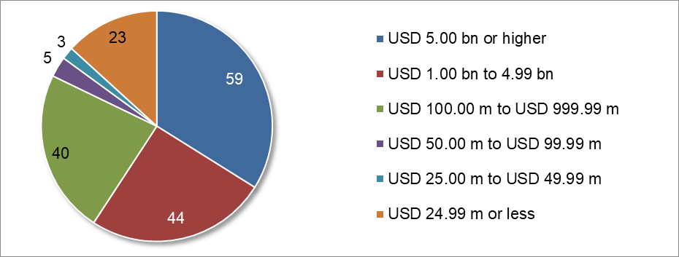Source: fDi Intelligence from The Financial Times Ltd

During the period January 2022 to December 2022, 133 projects were announced by 115 companies that had not previously had a project recorded by fDi Markets since 2003.

These investments created a total of 32,114 jobs and generated USD 30,148.38 million capital investment. To provide perspective on the size of these companies, the majority of these companies have a turnover of USD 350m or less.

Industry Analysis: Sectors

Out of a total of 36 sectors, the top five account for the majority of projects. Business services is the top sector accounting for one-eighth of projects tracked. Project volume in this sector peaked during 2022, with 38 projects tracked.

Number of FDI projects by year and sector
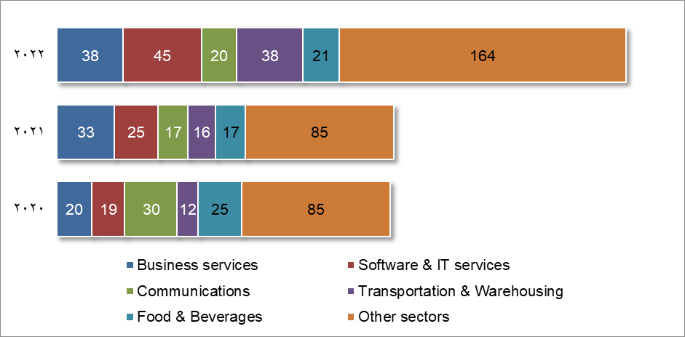Source: fDi Intelligence from The Financial Times Ltd

Renewable energy has generated the highest number of total jobs and greatest investment with a total of 26,257 jobs and USD 115.67bn investment. This sector also has the largest project size on average in terms of both investment and jobs creation.

FDI trends by sector
Sector | No of projects | Jobs Created |  | Capital investment
Sector | No of projects | Total | Average | Total (USD m) | Average (USD m)
Business services | 91 | 11,050 | 121 | 2,982.00 | 32.80
Software & IT services | 89 | 11,529 | 129 | 1,017.40 | 11.40
Communications | 67 | 5,716 | 85 | 3,839.30 | 57.30
Transportation & Warehousing | 66 | 10,672 | 161 | 8,172.80 | 123.80
Food & Beverages | 63 | 12,198 | 193 | 2,348.00 | 37.30
Renewable energy | 56 | 26,257 | 468 | 115,668.20 | 2,065.50
Financial services | 55 | 1,694 | 30 | 585.90 | 10.70
Industrial equipment | 27 | 1,167 | 43 | 339.70 | 12.60
Textiles | 23 | 5,145 | 223 | 304.50 | 13.20
Real estate | 19 | 7,186 | 378 | 6,323.90 | 332.80
Other sectors | 154 | 52,967 | 343 | 26,215.40 | 170.20
Total | 710 | 145,581 | 205 | 167,797.00 | 236.30
Source: fDi Intelligence from The Financial Times Ltd

Industry Analysis: Business activity

Out of a total of 17 business activities, the top five account for the majority of projects. Sales, Marketing & Support is the top business activity accounting for almost one-quarter of projects tracked. Project volume in this business activity peaked during 2022, with 69 projects tracked.

Number of FDI projects by year and business activity
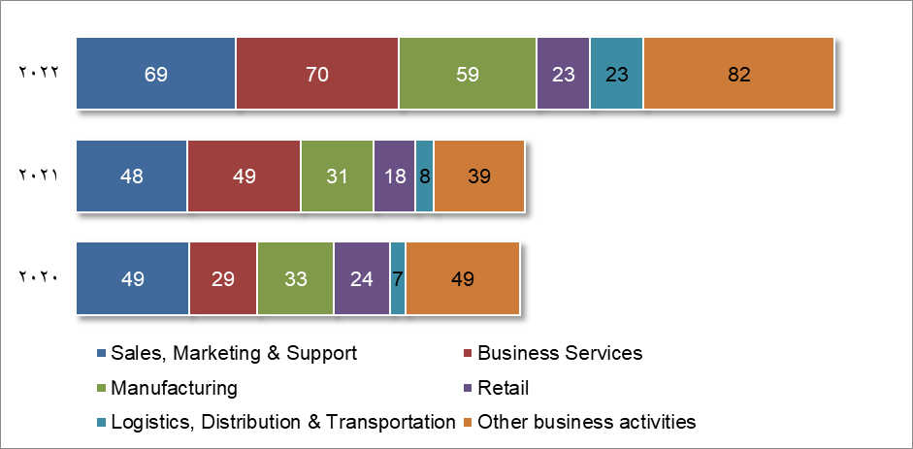Source: fDi Intelligence from The Financial Times Ltd

Manufacturing has generated the highest number of total jobs and greatest investment with a total of 65,603 jobs and USD 105.60bn investment. This business activity also has the largest project size on average in terms of both investment and jobs creation.

FDI trends by business activity
Business activity | No of projects | Jobs Created |  | Capital investment
Business activity | No of projects | Total | Average | Total (USD m) | Average (USD m)
Sales, Marketing & Support | 166 | 5,499 | 33 | 1,260.60 | 7.60
Business Services | 148 | 11,380 | 76 | 2,587.60 | 17.50
Manufacturing | 123 | 65,603 | 533 | 105,596.80 | 858.50
Retail | 65 | 8,268 | 127 | 1,234.00 | 19.00
Logistics, Distribution & Transportation | 38 | 12,338 | 324 | 8,228.00 | 216.50
ICT & Internet Infrastructure | 36 | 2,297 | 63 | 3,286.10 | 91.30
Electricity | 33 | 5,187 | 157 | 18,697.10 | 566.60
Research & Development | 24 | 2,131 | 88 | 557.00 | 23.20
Construction | 16 | 8,379 | 523 | 6,774.40 | 423.40
Headquarters | 16 | 2,552 | 159 | 309.70 | 19.40
Other business activities | 45 | 21,947 | 487 | 19,265.80 | 428.10
Total | 710 | 145,581 | 205 | 167,797.00 | 236.30
Source: fDi Intelligence from The Financial Times Ltd

Source Countries

Out of a total of 76 source countries, the top five account for almost half of projects. UAE is the top source country accounting for almost one-sixth of projects tracked. Project volume in this source country peaked during 2022, with 51 projects tracked.

Number of FDI projects by year and source country
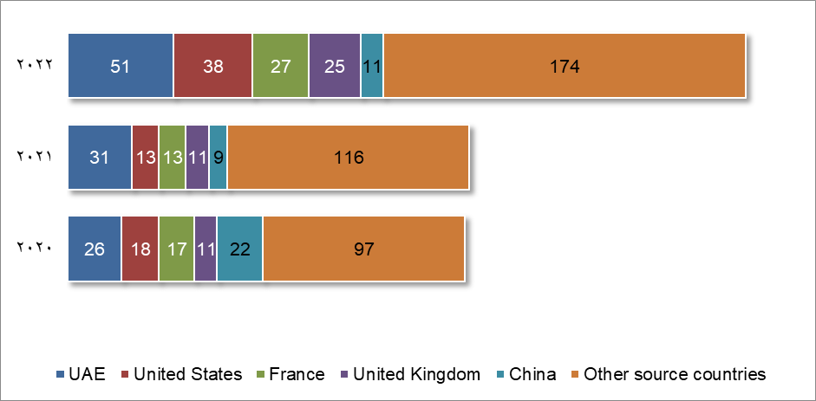Source: fDi Intelligence from The Financial Times Ltd

UAE has generated the highest number of total jobs and greatest investment with a total of 26,293 jobs and USD 32.85bn investment. India has the largest project size on average in terms of both investment and jobs creation.

FDI trends by source country
Source country | No of projects | No of companies | Jobs Created |  | Capital investment
Source country | No of projects | No of companies | Total | Average | Total (USD m) | Average (USD m)
UAE | 108 | 74 | 26,293 | 243 | 32,845.10 | 304.10
United States | 69 | 59 | 12,629 | 183 | 5,711.60 | 82.80
France | 57 | 41 | 15,988 | 280 | 25,121.00 | 440.70
United Kingdom | 47 | 40 | 9,758 | 207 | 17,684.20 | 376.30
China | 42 | 27 | 11,047 | 263 | 3,259.00 | 77.60
Germany | 32 | 24 | 6,043 | 188 | 6,578.10 | 205.60
India | 31 | 27 | 9,205 | 296 | 21,652.80 | 698.50
Switzerland | 29 | 20 | 1,682 | 58 | 521.40 | 18.00
South Africa | 26 | 18 | 2,976 | 114 | 2,408.80 | 92.60
Saudi Arabia | 21 | 16 | 5,674 | 270 | 7,760.90 | 369.60
Other source countries | 248 | 198 | 44,286 | 178 | 44,254.30 | 178.40
Total | 710 | 544 | 145,581 | 205 | 167,797.00 | 236.30
Source: fDi Intelligence from The Financial Times Ltd

Source cities

Out of a total of 235 source cities, the top five account for more than one-quarter of projects. Dubai is the top source city accounting for more than one-tenth of projects tracked. Project volume in this source city peaked during 2022, with 39 projects tracked.

Dubai has generated the highest number of total jobs, while Paris has the highest total investment. Abu Dhabi has the largest project size on average in terms of both investment and jobs creation.

FDI trends by source city
Source city | Projects |  | Companies |  | Jobs Created | Capital Investment (USD m)
Source city | No | % | No | % | Jobs Created | Capital Investment (USD m)
Dubai | 80 | 11.27 | 49 | 9.51 | 15,300 | 16,755.30
Paris | 36 | 5.07 | 25 | 4.85 | 12,983 | 19,459.60
London | 31 | 4.37 | 27 | 5.24 | 6,861 | 14,555.30
Abu Dhabi | 23 | 3.24 | 21 | 4.08 | 8,420 | 14,695.90
Riyadh | 16 | 2.25 | 11 | 2.14 | 4,331 | 6,180.10
Beijing | 15 | 2.11 | 7 | 1.36 | 2,681 | 1,452.80
Lagos | 15 | 2.11 | 11 | 2.14 | 1,179 | 266.50
Ebene | 14 | 1.97 | 6 | 1.17 | 778 | 1,134.80
San Francisco (CA) | 13 | 1.83 | 9 | 1.75 | 704 | 408.50
Johannesburg | 11 | 1.55 | 8 | 1.55 | 1,849 | 1,715.00
Beirut | 10 | 1.41 | 3 | 0.58 | 2,112 | 83.00
Istanbul | 10 | 1.41 | 10 | 1.94 | 2,547 | 336.10
Brussels | 9 | 1.27 | 6 | 1.17 | 599 | 113.40
Cape Town | 9 | 1.27 | 5 | 0.97 | 279 | 298.60
Nairobi | 9 | 1.27 | 7 | 1.36 | 581 | 124.00
Barcelona | 8 | 1.13 | 4 | 0.78 | 508 | 154.70
Mumbai | 8 | 1.13 | 6 | 1.17 | 1,256 | 126.90
Cairo | 7 | 0.99 | 6 | 1.17 | 166 | 157.70
Schindellegi | 7 | 0.99 | 1 | 0.19 | 140 | 57.40
Shenzhen | 7 | 0.99 | 5 | 0.97 | 471 | 95.60
Other source cities | 360 | 50.70 | 307 | 59.61 | 79,904 | 88,760.60
Not Specified | 12 | 1.69 | 10 | 1.94 | 1,932 | 865.30
Total | 710 | 100.00 | 544 | 105.63 | 145,581 | 167,797.00
Source: fDi Intelligence from The Financial Times Ltd

Destination Countries

Out of a total of 20 destination countries, the top five account for the majority of projects. Egypt is the top destination country accounting for almost two-fifths of projects tracked. Project volume in this destination country peaked during 2022, with 161 projects tracked.

Number of FDI projects by year and destination country
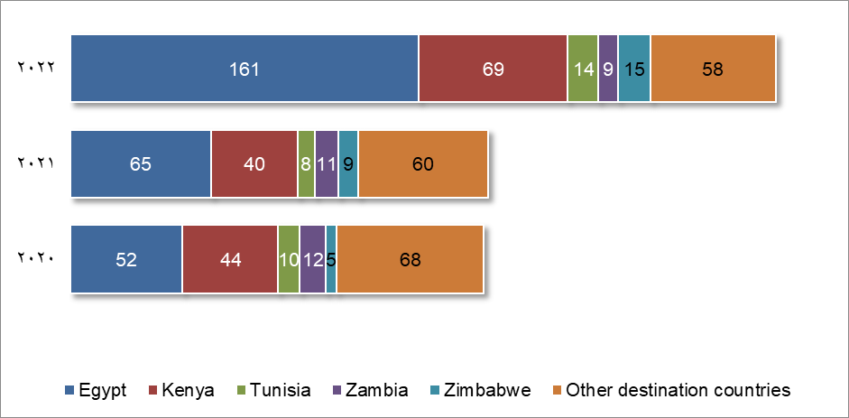Source: fDi Intelligence from The Financial Times Ltd

Egypt has received the highest number of total jobs and greatest investment with a total of 80,635 jobs and USD 124.11bn investment. Uganda has the largest project size on average in terms of both investment and jobs creation.

FDI trends by destination country
Destination country | No of projects | No of companies | Jobs Created |  | Capital investment
Destination country | No of projects | No of companies | Total | Average | Total (USD m) | Average (USD m)
Egypt | 278 | 229 | 80,635 | 290 | 124,110.40 | 446.40
Kenya | 153 | 136 | 14,532 | 94 | 4,899.00 | 32.00
Tunisia | 32 | 31 | 6,993 | 218 | 1,162.80 | 36.30
Zambia | 32 | 23 | 4,950 | 154 | 3,388.80 | 105.90
Zimbabwe | 29 | 24 | 7,200 | 248 | 7,019.10 | 242.00
Rwanda | 25 | 23 | 5,557 | 222 | 885.40 | 35.40
Ethiopia | 24 | 22 | 2,386 | 99 | 1,224.50 | 51.00
Cameroon | 23 | 19 | 2,944 | 128 | 496.40 | 21.60
Uganda | 23 | 21 | 7,117 | 309 | 10,836.30 | 471.10
Democratic Republic of Congo | 22 | 20 | 3,938 | 179 | 2,128.80 | 96.80
Other destination countries | 69 | 68 | 9,329 | 135 | 11,645.60 | 168.80
Total | 710 | 544 | 145,581 | 205 | 167,797.00 | 236.30
Source: fDi Intelligence from The Financial Times Ltd

Destination Cities

Out of a total of 94 destination cities, the top five account for one-third of projects. Cairo is the top destination city accounting for one-eighth of projects tracked. Project volume in this destination city peaked during 2022, with 49 projects tracked.

Ain Sokhna has both the highest total and highest average investment at USD 46.05bn overall and USD 2.88bn per project. Cairo has received the highest number of total jobs, while Port Said has the largest project size with 763 jobs per project on average.

FDI trends by destination city
Destination city | Projects |  | Companies |  | Jobs Created | Capital Investment (USD m)
Destination city | No | % | No | % | Jobs Created | Capital Investment (USD m)
Cairo | 95 | 13.38 | 86 | 16.70 | 16,309 | 3,985.80
Nairobi | 94 | 13.24 | 87 | 16.89 | 6,008 | 1,858.80
Kigali | 17 | 2.39 | 16 | 3.11 | 3,646 | 780.50
Ain Sokhna | 16 | 2.25 | 15 | 2.91 | 9,562 | 46,048.80
Tunis | 14 | 1.97 | 14 | 2.72 | 844 | 470.00
Addis Ababa | 10 | 1.41 | 10 | 1.94 | 605 | 567.10
Kampala | 10 | 1.41 | 10 | 1.94 | 830 | 258.70
New Cairo | 10 | 1.41 | 9 | 1.75 | 843 | 1,576.60
Douala | 9 | 1.27 | 8 | 1.55 | 712 | 150.40
6th of October City | 8 | 1.13 | 8 | 1.55 | 2,371 | 751.10
Harare | 8 | 1.13 | 8 | 1.55 | 1,407 | 807.40
Mombasa | 8 | 1.13 | 8 | 1.55 | 609 | 398.60
Alexandria | 7 | 0.99 | 7 | 1.36 | 2,930 | 878.50
Lusaka | 7 | 0.99 | 7 | 1.36 | 798 | 350.30
Kinshasa (Léopoldville) | 6 | 0.85 | 6 | 1.17 | 297 | 207.90
Port Said | 5 | 0.70 | 5 | 0.97 | 3,815 | 3,686.00
Ebene | 4 | 0.56 | 4 | 0.78 | 549 | 24.90
Yaounde | 4 | 0.56 | 4 | 0.78 | 222 | 33.90
Antananarivo | 3 | 0.42 | 3 | 0.58 | 148 | 150.50
Beni Suef | 3 | 0.42 | 3 | 0.58 | 927 | 60.00
Other destination cities | 94 | 13.24 | 94 | 18.25 | 27,451 | 16,278.10
Not Specified | 278 | 39.15 | 217 | 42.14 | 64,881 | 88,280.00
Total | 710 | 100.00 | 544 | 105.63 | 145,581 | 167,797.00
Source: fDi Intelligence from The Financial Times Ltd

Project Profiles

December 2022 - Bayerische Motoren Werke (BMW) into Egypt
Bayerische Motoren Werke (BMW) (Munich, Germany) is investing in the city of Giza, Egypt in the Automotive OEM sector in a Manufacturing project.
Germany-based car manufacturer BMW has established a $150m production plant in Giza, Egypt. The plant has the capacity to produce 10,000 units of BMW cars annually. It creates 600 jobs and will commence production in quarter one of 2023.
Jobs Created: 600 | Investment: USD 150.00 million
FDI project type: New

December 2022 - Creative Power Solutions (CPS) into Egypt
Creative Power Solutions (CPS) (Baden, Switzerland) is investing in the city of Sadat, Egypt in the Electronic components sector in a Manufacturing project.
Switzerland-based Creative Power Solutions, an engineering company in the sector of power generation and energy utilization, is to establish a E5.4m solar thermal collector production plant in Sadat City, Egypt. The project, to create 91 direct jobs, is in partnership with Sweden-based Absolicon, a provider of emission-free energy solutions, who will supply the plant with a solar collector production line. The plant will be constructed on a 2500 sq m plot. It is due to begin operations in quarter one of 2024 and will have the capacity to produce 50 megawatts per year.
Company contact: Majed Toqan (Chief Executive Officer)
Jobs Created: 91 | Investment: USD 5.75 million
FDI project type: New

December 2022 - Swissport International into Kenya
Swissport International (Zurich, Switzerland) is investing in the city of Mombasa, Kenya in the Transportation & Warehousing sector in a Logistics, Distribution & Transportation project.
Switzerland-based Swissport International, which offers passenger and cargo ground handling services, has established a presence in Mombasa, Kenya. Swissport's team offers aviation ground services, including passenger services and ramp handling, with the potential to expand to freighter handling, at Mombasa's Moi International Airport.
Company contact: Dirk Goovaerts (Chair, Global Cargo)
Jobs Created: 70 (est) | Investment: USD 164.60 million (est)
FDI project type: New

December 2022 - Copreci, a subsidiary of Mondragon Corporacion Cooperativa (MCC) into Egypt
Copreci, a subsidiary of Mondragon Corporacion Cooperativa (MCC) (Mondragon, Spain) is investing in Egypt in the Industrial equipment sector in a Manufacturing project.
Copreci, a household appliances manufacturer and subsidiary of Spain-based Mondragon Corporacion Cooperativa, is investing $7.6m to open a new manufacturing facility in Egypt in partnership with locally-based companies Fresh Electric, EBDA and El Araby. The facility will have a production capacity of 15 million valves for gas cookers and is set to open in April 2023. It will serve the domestic market. The company is supported by EBDA.
Jobs Created: 75 (est) | Investment: USD 7.60 million
FDI project type: New

December 2022 - Liquid Cloud (Liquid C2), a subsidiary of Econet Global into Kenya
Liquid Cloud (Liquid C2), a subsidiary of Econet Global (Ebene, Mauritius) is investing in the city of Nairobi, Kenya in the Communications sector in a Technical Support Centre project.
Liquid Cloud (Liquid C2), a subsidiary of Liquid Intelligent Technologies, itself a subsidiary of Mauritius-based Econet Group, has established a cyber security fusion centre in Nairobi, Kenya. The centre offers solutions for small and medium businesses requiring security operation centre services.
Company contact: David Behr (Chief Executive Officer, Liquid Cloud)
Jobs Created: 143 (est) | Investment: USD 12.70 million (est)
FDI project type: New

December 2022 - Voltalia into Egypt
Voltalia (Neuilly-sur-Seine, France) is investing in the city of Ain Sokhna, Egypt in the Renewable energy sector in a Manufacturing project.
France-based Voltalia, a renewable energy company, will develop a green hydrogen production facility in a greenfield site near Ain Sokhna port in the Suez Canal Economic Zone in Egypt. The project will have an initial capacity of 15,000 tonnes per year, this will be expanded to 150,000 tonnes per year of green hydrogen with an electrolyser capacity of up to an aggregate of 1GW supplied by an aggregate of 2.7GW of solar and wind power. The project is in partnership with TAQA Arabia, a subsidiary of Egypt-based QALAA Holding. It will serve the domestic market.
Company contact: Sebastien Clerc (Chief Executive Officer)
Jobs Created: 110 (est) | Investment: USD 4,954.70 million (est)
FDI project type: New

December 2022 - Nexgen Packaging into Kenya
Nexgen Packaging (Romeoville (IL), United States) is investing in the city of Athi River, Kenya in the Paper, printing & packaging sector in a Headquarters project.
US-based Nexgen Packaging, a manufacturer of brand identification and packaging products, has announced it is established its new regional headquarters in Athi River, Kenya. It will serve Africa and is located in the Export Processing Zone Athi-River.
Company contact: Jim Welch (Chief Executive Officer)
Jobs Created: 70 (est) | Investment: USD 21.80 million (est)
FDI project type: New

December 2022 - Tech Mahindra, a subsidiary of Mahindra Group into Egypt
Tech Mahindra, a subsidiary of Mahindra Group (Mumbai, India) is investing in the city of Cairo, Egypt in the Software & IT services sector in a Business Services project.
Tech Mahindra, a provider of solutions and services to the telecommunications industry and a subsidiary of India-based Mahindra Group, will establish a global delivery centre in Cairo, Egypt. It will create 1000 jobs by 2025. The new facility in Cairo assists Tech Mahindra's clients across various sectors; namely, telecom, oil and gas, BFSI (Banking, Financial Services, and Insurance), energy and utilities, and the public sector by leveraging Artificial Intelligence, Big Data and Analytics, Cloud and 5G technologies. The centre will serve local and global markets. The project is supported by the Information Technology Industry Development Agency (ITIDA).
Company contact: Ram Ramachandran (Vice President, Tech Mahindra)
Jobs Created: 1000 | Investment: USD 83.10 million (est)
FDI project type: New

December 2022 - Masdar, a subsidiary of Mubadala Investment Company into Seychelles
Masdar, a subsidiary of Mubadala Investment Company (Abu Dhabi, UAE) is investing in the city of Mahe, Seychelles in the Renewable energy sector in a Electricity project.
Masdar, a renewable energy company and a subsidiary of United Arab Emirates-based Mubadala Development, has entered a joint venture with Seychelles-owned Public Utilities Corporation (PUC) to open a five megawatt solar photovoltaic plant (PV) at Ile de Romainville on Mahe, Seychelles. The facility includes a 3.3 MWh energy storage system and a 33kV system that allows for the safe and stable supply of electricity from the PV power plant to the main island of Mahe. The project was financed by the Abu Dhabi Fund for Development.
Company contact: Mohamed Jameel Al Ramahi (Chief Executive Officer, Masdar)
Jobs Created: 44 (est) | Investment: USD 180.70 million (est)
FDI project type: New

December 2022 - Total Eren, a subsidiary of Eren Groupe into Zimbabwe
Total Eren, a subsidiary of Eren Groupe (Luxembourg, Luxembourg) is investing in Zimbabwe in the Renewable energy sector in a Electricity project.
Total Eren, a subsidiary of Luxembourg-based renewable energy company Eren Groupe, has anounced it will develop, finance and operate a solar photovoltaic project in Zimbabwe, together with UK-based Chariot. The solar farm will provide electricity for the Karo Platinum Project. It is expected to have an initial installed capacity of 30MWp with a potential extension of up to 300MWp.
Company contact: Fabienne Demol (Executive Vice President, Business Development, Total Eren)
Jobs Created: 44 (est) | Investment: USD 180.70 million (est)
FDI project type: New

December 2022 - Continental Wind Partners (CWP) into Djibouti
Continental Wind Partners (CWP) (Newcastle, Australia) is investing in Djibouti in the Renewable energy sector in a Manufacturing project.
CWP Global, a division of US-based wind farm developer Continental Wind Partners (CWP), has announced it has signed a memorandum of understanding with the Government of the Republic of Djibouti to develop a new 10GW renewable energy and green hydrogen hub in Djibouti. The project is to contribute to Djibouti's clean energy transition.
 | Alex Hewitt, chief executive officer, CWP Global, said, "We intend to utilise our experience in developing a leading PtX portfolio over the last five years to move quickly and collaboratively in developing this project in Djibouti, a country blessed with outstanding natural resources and a highly strategic location."
Company contact: CWP Global (Chairman)
Jobs Created: 110 (est) |  | Investment: USD 2,288.30 million (est)
FDI project type: New

December 2022 - AMEA Power into Egypt
AMEA Power (Dubai, UAE) is investing in Egypt in the Renewable energy sector in a Electricity project.
United Arab Emirates-based AMEA Power, a developer and operator of thermal and renewable power projects, is to build a 500 megawatt wind farm in the Red Sea Governate, Egypt. The investment is a joint venture with Japan-owned Sumitomo Corporation, who will own 40% equity in the project. The project, which forms part of a broader $1.1bn in-country strategy, has secured a power-purchase-agreement with a local partner.
Company contact: Hussain Al Nowais (Chairman)
Jobs Created: 163 (est) | Investment: USD 550.00 million (est)
FDI project type: New

December 2022 - AMEA Power into Egypt
AMEA Power (Dubai, UAE) is investing in the city of Aswan, Egypt in the Renewable energy sector in a Electricity project.
United Arab Emirates-based AMEA Power, a developer and operator of thermal and renewable power projects, will build, own and operate a 500 megawatt PV plant in Aswan, Egypt. The project, which forms part of a broader $1.1bn in-country strategy, has secured a power-purchase-agreement with a local partner.
Company contact: Hussain Al Nowais (Chairman)
Jobs Created: 163 (est) | Investment: USD 550.00 million (est)
FDI project type: New

December 2022 - Trade X into Kenya
Trade X (Mississauga, Canada) is investing in the city of Mombasa, Kenya in the Automotive OEM sector in a Logistics, Distribution & Transportation project.
Canada-based Trade X, which provides a global business-to-business, cross-border automotive trading platform, has opened a new shared bonded warehouse in Mombasa, Kenya. The warehouse is part of the company's new trading corridor which will serve automotive dealers in east African countries.
Company contact: Eric Gosselin (Senior Vice President, Global Business Development)
Jobs Created: 105 (est) | Investment: USD 22.20 million (est)
FDI project type: New

December 2022 - El Rashidi El Mizan, a subsidiary of Olayan Investments Company Establishment (OICE) into Egypt
El Rashidi El Mizan, a subsidiary of Olayan Investments Company Establishment (OICE) (Vaduz, Liechtenstein) is investing in the city of 6th of October City, Egypt in the Food & Beverages sector in a Manufacturing project.
El Rashidi El Mizan, a confectionary producer owned by Olayan Group, itself a subsidiary of Liechtenstein-based Olayan Investments Company Establishment, plans to invest $150m to expand its operations in 6th of October City, Egypt. The investment will result in six new production lines which will expand the company's food product offering.
Company contact: Sheriff William (Commercial Director, El Rashidi El Mizan)
Jobs Created: 622 (est) | Investment: USD 150.00 million
FDI project type: Expansion

December 2022 - Atos (Atos Origin) into Egypt
Atos (Atos Origin) (Bezons, France) is investing in the city of Cairo, Egypt in the Software & IT services sector in a Business Services project.
France-based Atos, which provides IT services, has expanded its operations in Egypt with the opening of a new global delivery centre. It currently has 350 employees with plans to hire 1000 staff by the end of 2023.
Company contact: Laura Fau (Head (Global), Press Relations)
Jobs Created: 1000 | Investment: USD 83.10 million (est)
FDI project type: Expansion

December 2022 - Tsingshan Holding Group into Zimbabwe
Tsingshan Holding Group (Wenzhou, China) is investing in Zimbabwe in the Transportation & Warehousing sector in a Logistics, Distribution & Transportation project.
China-based Tsingshan Holding, a steel manufacturer, is to invest in a new long cargo railway line in Zimbabwe. The 1000 km railway line will connect Tsingshan's three subsidiaries in Hwange, Chegutu and Chivhu, and the port of Beira, and it will be constructed alongside a rehabilitation of National Railways of Zimbabwe's old line.
Company contact: Wilfred Motsi (Project Manager (Zimbabwe))
Jobs Created: 70 (est) | Investment: USD 164.60 million (est)
FDI project type: New

December 2022 - DeFacto Perakende Ticaret AS into Egypt
DeFacto Perakende Ticaret AS (Turkey) is investing in Egypt in the Textiles sector in a Retail project.
Turkey-based DeFacto, a fashion retailer, has opened two new stores in Egypt. The company has opened a new store in Cairo located in the Maxim Mall and a second store in Alexandria located in the Green Plaza Mall. The new stores will serve the local market.
Company contact: Baris Sonmez (General Manager, Merchandising and Marketing)
Jobs Created: 50 (est) | Investment: USD 4.40 million (est)
FDI project type: New

December 2022 - Eni SpA into Tunisia
Eni SpA (Rome, Italy) is investing in the city of Tataouine, Tunisia in the Renewable energy sector in a Electricity project.
Italy-based ENI SpA, an energy conglomerate, has opened a new 10MW solar photovoltaic facility in Tataouine, Tunisia. The electricity produced will be supplied to STEG (Societe Tunisienne de l'Electricite et du Gaz) as agreed through a 20-year Power Purchase Agreement. Through the project Eni aims to contribute to the decarbonisation of Tunisia's energy system.
Jobs Created: 44 (est) | Investment: USD 180.70 million (est)
FDI project type: New

December 2022 - Trade X into Kenya
Trade X (Mississauga, Canada) is investing in the city of Nairobi, Kenya in the Software & IT services sector in a Sales, Marketing & Support project.
Canada-based Trade X, which provides a global business-to-business, cross-border automotive trading platform, has opened new office in Nairobi, Kenya. The office is part of the company's new trading corridor which will serve automotive dealers in east African countries.
Company contact: Shelley Keller (Director, Corporate Communications and Brand)
Jobs Created: 21 (est) | Investment: USD 5.20 million (est)
FDI project type: New

November 2022 - Masdar, a subsidiary of Mubadala Investment Company into Egypt
Masdar, a subsidiary of Mubadala Investment Company (Abu Dhabi, UAE) is investing in Egypt in the Renewable energy sector in a Electricity project.
Masdar, a renewable energy and sustainable urban development company that operates as a subsidiary of United Arab Emirates-based Mubadala Investment Company, will develop a 10 gigawatt onshore wind farm in Egypt. The project is a joint venture with Infinity Power and Hassan Allam Utilities. It is expected that the completed wind farm will produce 47,790 gigawatt hours of clean energy annually for the domestic market. Approximately 3200 jobs will be created for the operation and maintenance of the project after its construction.
Company contact: Mohamed Jameel Al Ramahi (Chief Executive Officer, Masdar)
Jobs Created: 3200 | Investment: USD 10,815.00 million (est)
FDI project type: New

November 2022 - Pfizer into Egypt
Pfizer (NYC (NY), United States) is investing in the city of Cairo, Egypt in the Pharmaceuticals sector in a Sales, Marketing & Support project.
US-based Pfizer, a pharmaceutical company, has opened a new office in Cairo, Egypt. With this, the company has announced that it will launch seven new products in Egypt in 2023, most of which will be involved in treating cancerous diseases.
Company contact: Patrick van der Loo (Regional President, Pfizer Middle East, Russia, and Africa)
Jobs Created: 36 (est) | Investment: USD 6.50 million (est)
FDI project type: New

November 2022 - Illovo Sugar Ltd, a subsidiary of Associated British Foods (AB Foods) into Rwanda
Illovo Sugar Ltd, a subsidiary of Associated British Foods (AB Foods) (London, United Kingdom) is investing in the city of Kigali, Rwanda in the Food & Beverages sector in a Manufacturing project.
Sugar producer Illovo Sugar, a subsidiary of UK-based Associated British Foods, has opened a packaging facility in Kigali, Rwanda. The company will import sugar from Malawi and Zambia to be packaged at the new factory, which is located at the Masaka Dry Port. It will serve the domestic market.
Company contact: Consolatha Karangwayire (Managing Director (Rwanda), Ilovo Sugar)
Jobs Created: 250 (est) | Investment: USD 46.00 million (est)
FDI project type: New

November 2022 - Copia Uganda, a subsidiary of Copia Global into Uganda
Copia Uganda, a subsidiary of Copia Global (Tatu City, Kenya) is investing in the city of Kampala, Uganda in the Consumer products sector in a Logistics, Distribution & Transportation project.
Copia Uganda, a subsidiary of Kenya-based Copia Global, which provides a consumer catalogue order and delivery system for nonperishable and durable goods, has opened a new 2230 sq m distribution facility in Kampala, Uganda. It serves the domestic market.
 | "As we expand our presence in Uganda, our new facility will grant us better capacity to serve our customers better and reduce the time it takes our customers to get their deliveries," said Diana Adeyemi, country director, Copia Uganda.
Company contact: Tim Steel (Chief Executive Officer)
Jobs Created: 390 (est) |  | Investment: USD 53.00 million (est)
FDI project type: New

November 2022 - Tsingshan Holding Group into Zimbabwe
Tsingshan Holding Group (Wenzhou, China) is investing in Zimbabwe in the Metals sector in a Extraction project.
China-based Tsingshan Holding, a steel manufacturer, is to establish a lithium mining and processing operation in Zimbabwe.
Company contact: Xiang Guangda (Chairman)
Jobs Created: 752 (est) | Investment: USD 274.30 million (est)
FDI project type: Expansion

About this Report

Disclaimer: This report was automatically created by fDi Markets using the criteria selected by the user. Whilst care has been taken in programming the analysis and presentation of data, abnormalities may occur. The Financial Times Ltd accepts no responsibility for the accuracy or otherwise of the content.

All investment project data and information is based on public information on company investment announcements. The Financial Times Ltd accepts no responsibility or otherwise for the accuracy of the data and information, nor does The Financial Times Ltd claim to track all investment projects.

Jobs data and capital investment data, if included, are not recorded for all projects and may include estimates. The Financial Times Ltd takes no responsibility for the accuracy or otherwise of the jobs and investment data.

The default currency used to record capital investment amounts is millions of US Dollars (USD). If the user has selected an alternative currency, the amounts stated are converted from US Dollars to the chosen currency using a conversion reference table. This table is periodically updated from published exchange rates. The Financial Times Ltd does not accept responsibility or otherwise for variances that occur between published exchange rates and the currency reference table used.

If you have any queries on the content of this report, please contact your designated account manager using the facility provided within the fDi Markets system.

